**ARTICLE TITLE : ROBOTIC CAR**

**1. Introduction**

This project is about creating a **Bluetooth-controlled robotic car** using an **Arduino UNO**. The car is equipped with **four motors** for movement, an **ultrasonic sensor** for obstacle detection, and a **Bluetooth module** to receive commands from a smartphone. The car can move forward, backward, turn left, turn right, and stop based on user input.

**2. Components Used & Their Role**

Here’s a detailed explanation of each component:

**Arduino UNO**

* The brain of the project. It processes inputs from the **Bluetooth module** and **ultrasonic sensor** and controls the motors accordingly.

**L298N Motor Driver Shield**

* This module controls the **four DC motors** and allows them to move forward, backward, left, or right by adjusting voltage and current.

**DC Motors (4 Motors)**

* These motors drive the wheels of the robot. Two motors are on the left side, and two are on the right side.

**Servo Motor**

* This motor helps rotate the ultrasonic sensor left and right to detect obstacles in multiple directions.

**HC-05 Bluetooth Module**

* This module enables **wireless communication** between the Arduino and a smartphone. It receives movement commands from the user via a Bluetooth app.

**Ultrasonic Sensor (HC-SR04)**

* Measures distance from obstacles. If an obstacle is detected within a certain range, the car either **stops** or **changes direction**.

**18650 Battery Holder (7.4V Power Supply)**

* Provides power to the Arduino and the motors. It consists of two **3.7V rechargeable batteries** connected in series.

**Switch**

* Acts as a power control switch to turn the robot ON or OFF.

**3. Circuit Diagram Explanation**

* The **Arduino UNO** is connected to the **motor driver shield**, which drives the **four motors**.
* The **Bluetooth module (HC-05)** is connected to the Arduino’s **TX/RX pins** to receive commands.
* The **Ultrasonic sensor (HC-SR04)** is connected to the Arduino to measure the distance of obstacles.
* The **Servo motor** is connected to the Arduino to rotate the ultrasonic sensor for better obstacle detection.
* The power supply from the **18650 batteries** provides 7.4V to the circuit, which is enough to run the motors and Arduino.

**4. Working Principle**

**Step-by-Step Process:**

1. The **user sends a command** from a smartphone app via Bluetooth.
2. The **Bluetooth module (HC-05)** receives the command and sends it to the **Arduino UNO**.
3. The **Arduino processes the command** and sends signals to the **L298N motor driver shield** to control the **motors' movement**.
4. The **car moves** forward, backward, left, or right based on the command received.
5. The **ultrasonic sensor** continuously checks for obstacles in front of the car.
6. If an **obstacle is detected**, the car **stops** or **changes direction** to avoid a collision.
7. The **servo motor rotates** the ultrasonic sensor left and right to scan a wider area for obstacles.

**5. Code Explanation (Basic Logic)**

The Arduino code includes:

* **Bluetooth Communication** → Reads commands like ‘F’ for forward, ‘B’ for backward, etc.
* **Motor Control** → Adjusts motor speed and direction using the **L298N motor driver shield**.
* **Ultrasonic Sensor Functionality** → Measures distance from obstacles and stops the car if an obstacle is too close.
* **Servo Motor Rotation** → Moves the ultrasonic sensor left and right for better obstacle detection.

**6. Applications & Future Scope**

**Current Applications**

* **Wireless control** of a robotic vehicle.
* Can be used for **security patrols** in restricted areas.
* Helpful for **home automation** (e.g., automated moving robots).

**Future Enhancements**

* Adding **AI-based navigation** for self-driving capability.
* Implementing **voice control** instead of manual commands.
* Integrating **GPS** for outdoor navigation.

Circuit connections:

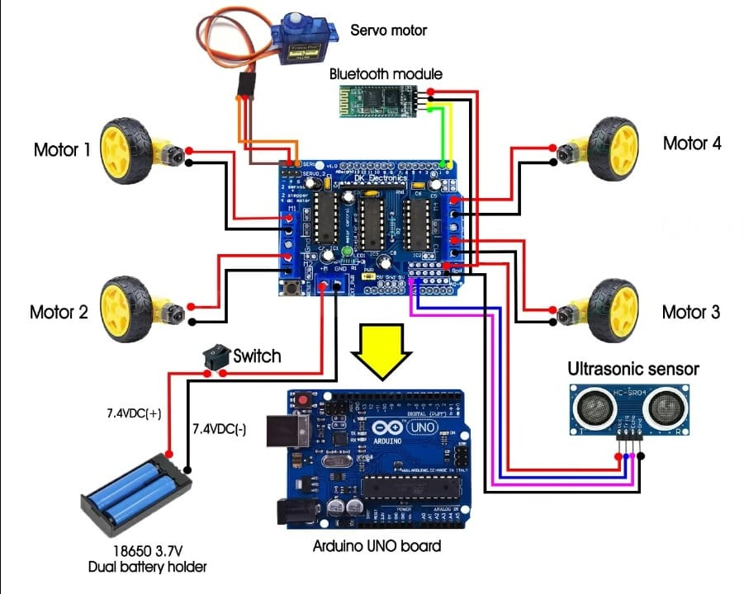

Advanced features made by me :

I developed a app to control the obstacle mode and Bluetooth mode without connecting USB cable to our robot car.

Here,

We used ListPicker, buttons and bluetoothClient1.

How it works.

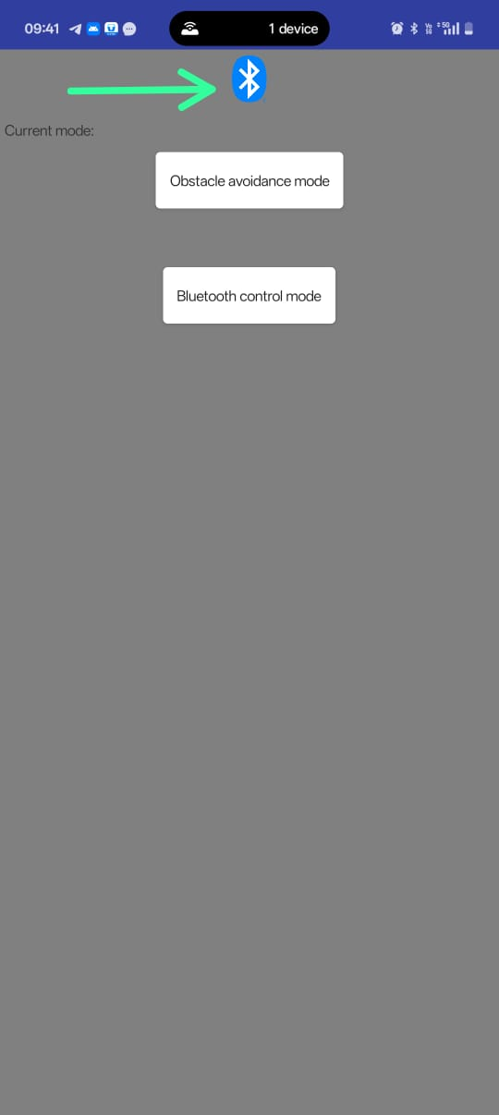

STEP 1 : go to the pingo app developed by us.Click on Bluetooth ICON and connect it to HC-05 Bluetooth module

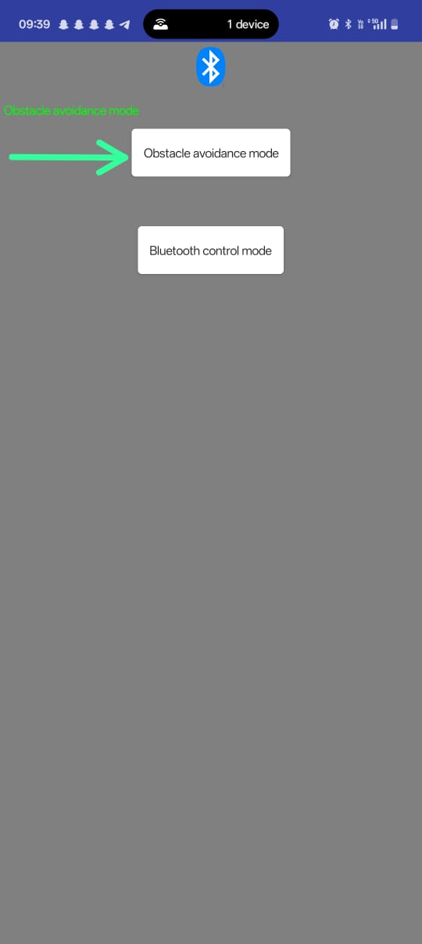

STEP 2: on obstacle mode here it works automatic by using already programmed code in Arduino uno board

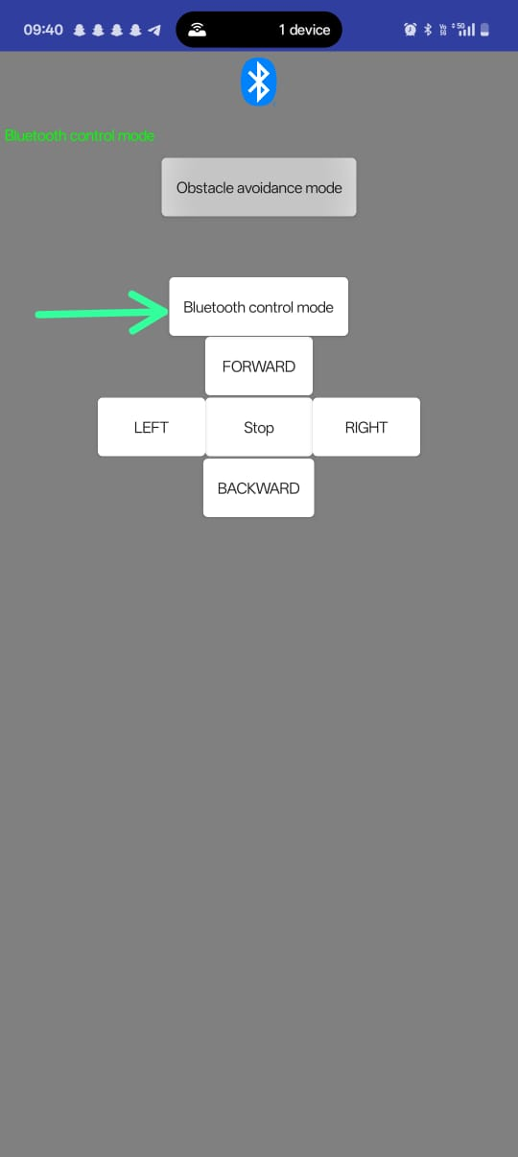

Step 3 :NOW press reset button in shield board and turn on Bluetooth control mode

Now we can operate robot through BUTTONS shown above.

Arduino code : #include <Servo.h>

#include <AFMotor.h>

#define Echo A1

#define Trig A0

#define motor 10

#define Speed 170

#define spoint 103

char value;

int mode = 0;

int distance;

int Left;

int Right;

int L = 0;

int R = 0;

int L1 = 0;

int R1 = 0;

Servo servo;

AF_DCMotor M1(1);

AF_DCMotor M2(2);

AF_DCMotor M3(3);

AF_DCMotor M4(4);

void Bluetoothcontrol() {

while (1) {

if (Serial.available() > 0) {

value = Serial.read();

Serial.println(value);

}

if (value == 'F') {

forward();

} else if (value == 'B') {

backward();

} else if (value == 'R') {

left();

} else if (value == 'L') {

right();

} else if (value == 'S') {

Stop();

}

}

}

void Obstacle() {

while (1)

{

distance = ultrasonic();

if (distance <= 12) {

Stop();

backward();

delay(100);

Stop();

L = leftsee();

servo.write(spoint);

delay(800);

R = rightsee();

servo.write(spoint);

if (L < R) {

right();

delay(500);

Stop();

delay(200);

} else if (L > R) {

left();

delay(500);

Stop();

delay(200);

}

} else {

forward();

}

}

}

int ultrasonic() {

digitalWrite(Trig, LOW);

delayMicroseconds(4);

digitalWrite(Trig, HIGH);

delayMicroseconds(10);

digitalWrite(Trig, LOW);

long t = pulseIn(Echo, HIGH);

long cm = t / 29 / 2; //time convert distance

return cm;

}

void forward() {

M1.run(FORWARD);

M2.run(FORWARD);

M3.run(FORWARD);

M4.run(FORWARD);

}

void backward() {

M1.run(BACKWARD);

M2.run(BACKWARD);

M3.run(BACKWARD);

M4.run(BACKWARD);

}

void right() {

M1.run(BACKWARD);

M2.run(BACKWARD);

M3.run(FORWARD);

M4.run(FORWARD);

}

void left() {

M1.run(FORWARD);

M2.run(FORWARD);

M3.run(BACKWARD);

M4.run(BACKWARD);

}

void Stop() {

M1.run(RELEASE);

M2.run(RELEASE);

M3.run(RELEASE);

M4.run(RELEASE);

}

int rightsee() {

servo.write(20);

delay(800);

Left = ultrasonic();

return Left;

}

int leftsee() {

servo.write(180);

delay(800);

Right = ultrasonic();

return Right;

}

void setup() {

Serial.begin(9600);

pinMode(Trig, OUTPUT);

pinMode(Echo, INPUT);

servo.attach(motor);

M1.setSpeed(Speed);

M2.setSpeed(Speed);

M3.setSpeed(Speed);

M4.setSpeed(Speed);

}

void loop() {

while (Serial.available()) {

if (Serial.available() > 0) {

char input = Serial.read();

Serial.println(input);

if (input =='O'&&mode==0) {

Serial.println("Obstacle mode");

mode = 1;

Obstacle();

}

else if (input =='B'&&mode==0) {

Serial.println("Bluetooth mode");

mode = 2;

Bluetoothcontrol();

}

}

}

}

// Ultrasonic sensor distance reading function